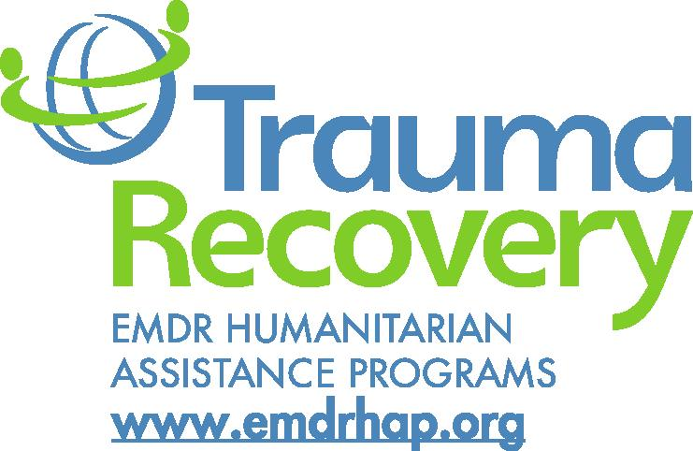

Start a Trauma Recovery Network Association in Your Community
in 30 Days or Less!
Trauma Recovery/HAP Mission: To increase the capacity for effective treatment of psychological trauma in under-served communities anywhere in the world.
Trauma Recovery Network Purposes: to assist in times of emergency with pro bono services and to address ongoing circumstances contributing to trauma in their local communities; to network with the local emergency management system and with other groups within the TRN to share informational resources and lessons learned; to engage in outreach to both the general public and community leaders on the nature and treatment of psychological stress.

1. Form an initial Steering Committee of three people who are signed up as TR/HAP volunteers to lead the process. All individuals must have completed an EMDRIA authorized Basic Training in EMDR therapy; certification in EMDR therapy is not required.
2. Choose your association’s coordinator and identify your EMDRIA approved consultant.
3. Send the following information to the Trauma Recovery/HAP Program and Community Development Director.
- Names of the TRN Association Members – all TRN Members must be registered as Trauma Recovery/HAP volunteers and must sign a TRN Member Agreement. This agreement can be found in the member’s volunteer account, on line at emdrhap.org.
- Names, telephone numbers and email addresses for the TRN Association coordinator and the EMDRIA approved consultant.
- The requested name for the association which should describe the specific area in which you wish to be active, e.g. TRN Association of Tulsa, TRN Association of _____ County.
- A brief statement of anticipated activities in furtherance of the Mission and Model to deliver the Purposes.
4. Once the information is received and the name accepted or modified and assigned, the association will be added to the Trauma Recovery Network database and will be listed on line in the TRN section at emdrhap.org.
5. The Program and Community Development Director signs the TRN Association Agreement and you are off and running.
Please review the obligations of
TRN Members and TRN Associations provided below:
TRN Member Obligations
1. Conduct activities in accordance with the standards set by the EMDR community.
2. Maintain and comply with professional practice insurance and licensing requirements.
3. Maintain current information in the online volunteer account.
4. Provide any pro bono services to individuals in accordance with the TRN manual maintained by Trauma Recovery/HAP.
5. Not conduct personal business while acting as a TRN Member.
6. Conduct all activities as a TRN Member in furtherance of the Mission and Model to deliver the Purposes and prohibits the promotion of commercial or private trainings.
7. Use TRN Member contact information, including email lists or accounts, only in furtherance of the Mission and to deliver the Purposes.
8. Use the Name and Logos only in a manner that is consistent with Trauma Recovery/HAP’s ownership and only in the form provided by Trauma Recovery/HAP.

TRN Association Obligations
1. Conduct all activities in furtherance of the Mission and to deliver the Purposes.
2. TRN Association Members have entered into a TRN Member Agreement and will maintain good standing.
3. Use all funds Trauma Recovery/HAP distributes in accordance with all terms and conditions on the use of such funds.
4. Use TRN Member contact information, including email lists or accounts, only in furtherance of the Mission and to deliver the Purposes.
5. Use the Name and Logos only in a manner that is consistent with Trauma Recovery/HAP’s ownership and only in the form provided by Trauma Recovery/HAP.
6. Not discriminate in the provision of services or the management of TRN Members on any basis that is prohibited by law or Trauma Recovery/HAP policy.
7. Not endorse goods or services of third parties.
8. Not engage in activities that are intended to influence legislation or that endorse or oppose candidates for public office.

